

**TRIBHUVAN UNIVERSITY**

**Institute of Science and Technology**

**A Project Report on**

**“JOB RECOMMENDATION SYSTEM”**

**Submitted to:**CSIT Department  
Bhaktapur Multiple Campus  
Dudhpati, Bhaktapur

**In partial fulfillment of the requirement for  
Bachelor's Degree in  
Computer Science and Information Technology**

**Submitted By**Chetan Raj Budhathoki (T.U. Roll No. 20232/075)  
Bimal Shrestha (T.U. Roll No. 20227/75)  
Nabin Bhandari (T.U. Roll No. 20247/075)

**May 2023**

**Certificates**

**Supervisor Recommendation**

This is to certify that the report entitled “Job Recommendation System using Cosine Similarity Algorithm” has been prepared under my supervision by **Bimal Shrestha (20227/075), Chetan Raj Budhathoki (20232/075) and Nabin Bhandari (20247/075)** in partial fulfillment of the requirements for the degree of B.Sc. in Computer Science and Information Technology.

I have read and approved the report and recommend it for evaluation. The report meets the required standards for the degree program and demonstrates a high level of understanding and competence in the field of computer science and information technology.

…………………..……………..…

**Saroj Maharjan**

Supervisor/Visiting Faculty

CSIT Department

Bhaktapur Multiple Campus

Dudhpati-02, Bhaktapur



**Certificate of Approval**

This is to certify that this project prepared by **Bimal Shrestha (20227/075), Chetan Raj Budhathoki (20232/075) and Nabin Bhandari (20247/075)** entitled “Job Recommendation System using Cosine Similarity Algorithm” in partial fulfillment of the requirements for the degree of B.Sc. in Computer Science and Information Technology has been well studied. In our opinion, it is satisfactory in the scope and quality of a project for the required degree.

…………………..………..…  
**Sushant Paudel**  
Department Head  
CSIT Department  
Bhaktapur Multiple Campus  
Dudhpati-02, Bhaktapur

…………………..………..… **Saroj Maharjan**  
Supervisor/Visiting Faculty  
CSIT Department  
Bhaktapur Multiple Campus  
Dudhpati-02, Bhaktapur

…………………..………..…  
**Internal Examiner**  
CSIT Department  
Bhaktapur Multiple Campus  
Dudhpati-2, Bhaktapur

…………………..………..…  
**External Examiner**  
Central Department of  
Computer Science and IT  
Tribhuvan University  
Kritipur, Nepal

**Acknowledgment**

The success and final outcome of this assignment required a lot of guidance and assistance from many people and we feel extremely fortunate to have got all this all along the completion of our assignment work. Whatever we have done is only due to such guidance and assistance and we would not forget to thank them. We take this opportunity to express our profound gratitude and deep regards to our supervisor **Mr. Saroj Maharjan** for his exemplary guidance, monitoring and constant encouragement throughout the course of this thesis. The blessing, help and guidance given by him from time to time shall carry us a long way in the journey of life on which we were about to embark.

We could not have completed this project without help from our college “Bhaktapur Multiple Campus” which gave us supportive hands before us academically, also regarding other activities related to Information Communication Technology as well as extracurricular activities that we got to participate in. It gave us a family-like environment.

We also take this opportunity to express a deep sense of gratitude to **Mr. Sushant Poudel**, coordinator, BMC College, for his cordial support, valuable information and guidance, which helped us in completing this task through various stages.

**Project Team**

Chetan Raj Budhathoki

Nabin Bhandari

Bimal Shrestha

**Abstract**

Job searching has become increasingly challenging in recent times, with manual job portals requiring users to spend countless hours searching for job vacancies, leading to inefficiency and time wastage. To tackle this problem, this report introduces a job recommendation system that utilizes content-based filtering and cosine similarity algorithms to suggest relevant job opportunities to job seekers based on their user profile and job vacancy requirements. The system aims to improve the job search experience for both job seekers and employers by providing a personalized and efficient approach to job searching.

This report discusses the design, implementation, and evaluation of the job recommendation system. The system was developed using PHP and a MYSQL database was used to store the job listings. The user interface was designed to be user-friendly and easy to navigate. A user study was conducted to evaluate the system's effectiveness, and the results showed that the system successfully recommended relevant jobs to job seekers.

The job recommendation system has the potential to significantly impact the job market by allowing employers to better manage their resources and receive applications from interested job seekers, while also providing job seekers with a more efficient way to search for relevant job opportunities. Overall, this system is a valuable tool for job seekers and employers alike, and has the potential to transform the job search experience.

***Keywords: Recommendation system, Cosine similarity, Content-based filtering***

**List** **of** **Abbreviations**

|  |  |
| --- | --- |
| HTML | Hyper Text Markup Language |
| CSS | Cascading Style Sheets |
| JS | JavaScript |
| CV | Curriculum Vitae |
| PHP | Hypertext Preprocessor |
| SQL | Structured Query Language |
| DBMS | Database Management System |
| TF-IDF | Term Frequency-inverse document frequency |
| ER | Entity Relationship |

**Table of Contents**

**ACKNOWLEDGMENT……………………………………………………………………..I**

**ABSTRACT.…………………………………………………………………………………II**

**TABLE OF CONTENTS…………………………………………………………………..III**

**LIST OF ABBREVIATIONS………………………………………………………………IV**

**LIST OF FIGURES.………………………………………………………………………...V**

**LIST OF TABLES……………………………………………………………………….…VI**

**CHAPTER 1: INTRODUCTION…………………………………………………………...1**

* 1. INTRODUCTION………………………………………………………………………1
  2. PROBLEM STATEMENT……………………………………………………………...2
  3. OBJECTIVES……………………………………………………...................................3
  4. SCOPE AND LIMITATIONS……………………………………………………..........4
  5. DEVELOPMENT METHODOLOGY………………………………………………...5
  6. REPORT ORGANIZATION……………………………………………………...........6

**CHAPTER 2: BACKGROUND STUDY AND LITERATURE REVIEW………………...**

2.1 BACKGROUND STUDY…………………………………………………………….

2.2 LITERATURE REVIEW……………………………………………………………….

**CHAPTER 3: SYSTEM ANALYSIS…………………………………………………………**

3.1 SYSTEM ANALYSIS………………………………………………………………...

3.1.1 REQUIREMENT ANALYSIS ………………………………………………..

3.1.1.1 FUNCTIONAL EQUIREMENT……………………………………

3.1.1.2 NON-FUNCTIONAL REQUIREMENT……………………………………..

3.1.2 FEASIBILITY ANALYSIS……………………………………………………

3.1.2.1 TECHNICAL………………………………………………………

3.1.2.2 OPERATIONAL………………………………………………………………...

3.1.2.3 ECONOMIC………………………………………………………..

3.1.2.4 SCHEDULE……………………………………………………………………..

3.1.3 ANALYSIS………………………………………………………………………

3.1.3.1 DATA MODELING (ER DIAGRAM)…………………………………………

3.1.3.2 PROCESS MODELING USING DFD………………………………………...

**CHAPTER 4: SYSTEM DESIGN……………………………………………………………**

4.1 DESIGN………………………………………………………………………………

4.1.1 DATABASE DESIGN…………………………………………………………

4.1.2 FORMS AND REPORT DESIGN………………………………………………

4.1.3 INTERFACE DESIGN…………………………………………………………..

4.2 ALGORITHM DETAILS…………………………………………………………….

**CHAPTER 5: IMPLEMENTATION AND TESTING……………………………………...**

5.1 IMPLEMENTATION…………………………………………………………………...

5.1.1 TOOLS USED……………………………………………………………………….

5.1.2 IMPLEMENTATION DETAILS OF MODULES……………………………...

5.2 TESTING**………………………………………………………………………………...**

5.2.1 TEST CASES FOR UNIT TESTING……………………………………………...

5.2.2 TEST CASES FOR SYSTEM TESTING………………………………………….

5.3 RESULTANALYSIS**……………………………………………………………………**

**CHAPTER 6: CONCLUSION AND FUTURE RECOMMENDATION ………………...**

6.1 CONCLUSION…………………………………………………………………………

6.2 FUTURE RECOMMENDATIONS……………………………………………………

**REFERENCES..………………………………………………………………………………**

**ANNEX I: QUESTIONNAIRE………………………………………………………………**

**List of Figures**

1.1 Methodology diagram of Project…………………………………………………………...

3.1 Functional Requirement Module…………………………………………………………...

3.2 Gant Chart of the project……………………………………………………………………

3.3 ER Diagram………………………………………………………………………………...

3.4 0-Level DFD………………………………………………………………………………..

3.5 1-Level DFD………………………………………………………………………………..

3.6 2-Level DFD………………………………………………………………………………..

4.1 Database Design……………...……………………………………………………………..

**List of Tables**

3.1 Table of the task schedule…………………………………………………………………..

5.1 Unit Test Cases for Application…………………………………………………………….

5.2 Test Case for applying job………………………………………………………………….

5.3 Test Case for Listing all jobs……………….……………………………………………….

5.4 Test Case for handling large volume of data………………………………………………..

5.5 Test Case for the accuracy of the algorithm………………………………………………...

**CHAPTER 1**

**INTRODUCTION**

**1.1 INTRODUCTION**

A Recommendation System is a subclass of information filtering system that seeks to predict the "preference" a user would give to an item. In most of the existing job portal systems, users or job seekers have to manually search for the different job vacancies and apply for those job vacancies. The Job Recommendation System has been developed to override the problems prevailing in the practicing manual system. This software is supported to eliminate and, in some case, it reduces the hardships faced by the existing system. Moreover, this system is designed for particular need of the company to carry out operations in a smooth and effective manner.

The application is reduced as much as possible to avoid errors while entering the data. It also provides error messages while entering invalid data. No formal knowledge is required for the user to use this system. Thus, by this all it proves that it is user friendly.

Job Recommendation System, as described above can lead to error free, reliable and fast management systems. It can assist the user to concentrate on their own other activities rather than concentrating on record keeping.

Every organization, whether big or small, has challenges to overcome and manage the information of vacancy, job, vacancy, job candidate, interview schedule. Through this system, every organization can have their own personal account, post the jobs, and view the applications sent by different job seekers for those jobs. And also, this system is very useful for those people who are seeking job opportunities. This system will ultimately allow employers to better manage resources. This system is equally advantageous for job seekers as they can manually search for the jobs in which they are interested and apply for that job. Another important feature of this system is it recommends the job seeker, a list of relevant jobs matching the content of user profile and job specification of job vacancies using content-based filtering and cosine similarity algorithm. Thus, this unique feature of the system makes it different from existing job portal system.**1.2** **Problem statement**

In existing Job Portal Systems such as merojob.com, indeed.com, SimplyHired.com etc., job seekers have to manually search for the job vacancies that are suitable to them.

So our motive is to solve this problem by introducing the system in which job seekers can register their account and upload their resume and create their own profile based on their experience and skills. According to their profile, our system suggests the list of the jobs that are relevant to them.

Relevant job recommendations are therefore crucial for a good user experience. Here we present a method to compute the similarities between user profiles and job specification related to different jobs using cosine similarities and provide a list of jobs that are according to their similarities.

**1.3** **Objectives**

The general objective of the project is to develop a web-based application where different organizations can post job vacancies and job seekers can search and apply for the job suitable for them as well as this system will also recommend the job relevant to their job. Another objective is to build the application program to reduce the manual approach of managing the jobs and vacancy. The main objective of this system is to showcase the available jobs to the users and recommend the jobs best to their abilities, experiences and expertise. However thorough set of objectives are listed below:

**1. Personalization:** To provide personalized job recommendations to job seekers based on their skills, Experience, and preferences. This will help job seekers to find job opportunities that are relevant to their career goals and aspirations.

**2. Accuracy:** To provide accurate job recommendations that match the job seeker’s skills and qualifications with the job requirements and qualifications provided by the employer which will increase the chances of successful job placements for both job seekers and employers.

**3. Efficiency:** To provide and efficient platform that connects job seekers with potential employers, reducing the time and effort required to find suitable job opportunities.

**1.4 Scope and Limitation**

**1.4.1 Scope**

Job recommendation systems have a wide scope in today's job market, since the technology advancement have changed the working principle of every organization and it has made general public to use the technology in a massive way. Job recommendation systems also have a wide scope in the context of Nepal, where the job market is rapidly growing and changing.

Our system ensures that the website is available, accessible, and reached to every Nepali job seeker and recruiter. In the near future this recommendation system will fulfill the necessity in a speedy manner.

**The scope of the system can be listed as follow:**

It can act as a platform for maintaining job seeker and employer records, posting job details and job application lists, providing right job for right person.

It can act as a system for the large data collection from the different users (job seekers and employers), that can be processed for different use cases.

• Maintain job seeker and employer records.  
• Provide customized job postings.  
• Maintain job posting details.  
• Maintain the job applications lists.

**1.4.2 Limitation**

The limitations of the project are listed below:

**1. Limited data:** A job recommendation system relies heavily on data to generate recommendations. If there is limited data available, the system may not be able to provide accurate or relevant job recommendations.

**2. Inability to handle context:** Cosine similarity is a context-free measure of similarity and may not be able to handle context-specific job requirements. For example, a job that requires a certain level of experience may be recommended to job seekers with similar skills but without the required experience.

**1.5 Development Methodology**

Since the requirements were pretty much clear from the beginning and time was allocated likewise, we found waterfall model as the best fit to this system as the System Development Lifecycle (SDLC).

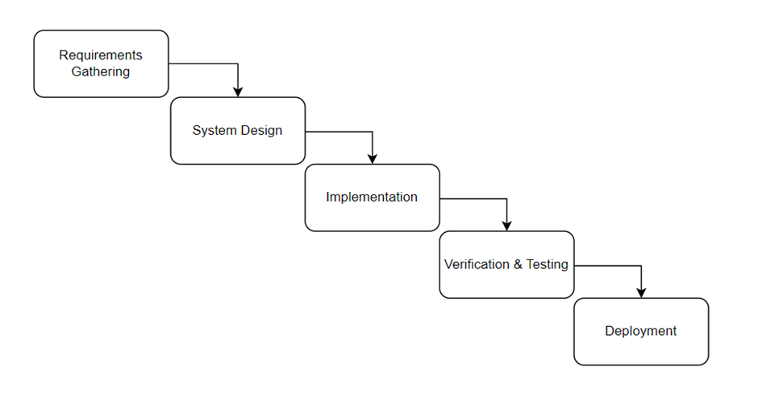Here’s how waterfall model was applied:

Figure 1: Methodology diagram of Project

**1.5.1 Requirement Gathering**

The first step in the waterfall model is to gather all the requirements for the job recommendation system. We tried understanding the user requirements, business goals and system constraints. Clearly defining the objectives of the system and the kind of users interacting with the system like job seekers, recruiters, understanding their specific requirements and the level of personalization needed. Data sources were identified that will be used to provide job recommendations such as job postings, candidate profiles and user behavior data.

**1.5.2 Design**

Once the requirements were identified we designed the system architecture which involved creating a high-level design for the job recommendation system where we defined the data models, algorithms, and the overall system architecture. We also considered the user interface where that will be used by users to easily interact with the system.

**1.5.3 Implementation**

In this phase, the job recommendation system was built according to the design specifications. We implemented the algorithms and data models, as well as the user interface and other features that were specified in the design phase. We also conducted thorough testing to ensure the system is functioning as intended.

**1.5.4 Testing**

In the testing phase, we conducted comprehensive testing to ensure that the job recommendation system is free of bugs and meets all the requirements. We conducted unit testing, integration testing, and system testing to ensure that the system is working as expected.

**1.5.5 Deployment**

Once the job recommendation system was thoroughly tested and validated, we deployed it in a production environment. This involved installing the system on the production servers and configuring it for use, by end-users.

**1.5.6 Maintenance**

After the job recommendation system was deployed, we have been constantly monitoring it to ensure that it's working properly. Any bugs that may arise will be fixed and necessary updates to the system will be provided to keep it up-to-date with changing user needs.

**1.6 Report Organization**

The report is divided into seven chapters along with their descriptions, and also there include some additional sections of references and a conclusion.

**1.6.1 Chapter 1: Introduction**

In this chapter, the project “Job Recommendation System” is described. This chapter discusses the questions: what is the project about, what problems does the project address, what are the goals of the project, etc.?

**1.6.2 Chapter 2: Background Study and Literature Review**

In this chapter, the underlying concept and theories used in the project are discussed. As the project is to create a system (web application) As the project is to create a system (web application), that focuses on recommending jobs based on the cosine similarity between contents from different parties. Different research article done on recommending systems are mentioned and discussed.

**1.6.3 Chapter 3: System Analysis**

In this chapter, the analysis of the system is done in various aspects such as requirement analysis, various feasibility analyses, and also a brief analysis of the overall system is done.

**1.6.4 Chapter 4: System Design**

In this chapter, the main system design of the system is discussed and various respective system designs drawn are discussed. As the system is object-oriented based on the class, object, state, sequence, and activity diagrams, components diagrams, deployment diagrams, and also the major algorithm used in the project segment intersection, linear interpolation, and multi-layer perceptron neural network are discussed.

**1.6.5 Chapter 5: Implementation and Testing**

In this chapter, how the project was conducted, what programming languages, CASE tools, and technologies were used for completing the project are discussed, and also what testing methodologies and test cases conducted during the implementation period are discussed.

**1.6.6 Chapter 6: Conclusion and Recommendation**

In this chapter the summary of the overall project, what was achieved, and what future enhancement in the project can be done for the project is discussed.

**CHAPTER 2  
BACKGROUND STUDY AND LITERATURE REVIEW**

**2.1 Background Study**

The fundamental theories, general concepts, and terminologies related to the project are discussed below:

**2.1.1 Fundamental Concepts**

**2.1.1.1 Recommender systems**

A recommender system is a subclass of information filtering system that seeks to predict the "rating" or "preference" that a user would give to an item. Recommender systems are widely used in various applications, including e-commerce, social media, and job search engines.

**2.1.1.2 Job Matching**

Job matching refers to the process of matching job seekers with job postings that best fit their skills, experience, and preferences. Job recommendation systems use a variety of techniques, such as machine learning and candidate matching algorithms, to provide accurate and relevant job recommendations.

**2.1.2 Theories**

**2.1.2.1 Cosine Similarity**

Cosine similarity is a mathematical technique used to measure the similarity between two vectors in a high-dimensional space. It is commonly used in information retrieval and recommendation systems to compare the similarity between documents or items based on their content or attributes.

The cosine similarity is calculated as the cosine of the angle between two vectors. It ranges from -1 to 1, with values closer to 1 indicating a higher degree of similarity between the two vectors.

**2.1.2.1 Content-based filtering**

Content-based filtering is a technique used in recommendation systems that recommends items to users based on their similarity to items that the user has previously shown interest in or interacted with. The system uses information about the content or attributes of the items to identify other items that are similar in some way.

**2.1.3 Terminologies**

**2.1.3.1 Job recommendation system**

A system that recommends job openings to job seekers based on their skills, experience, and preferences.

**2.1.3.2 Content-based filtering**

A technique that matches job seekers with job openings based on the similarity of their skills, experience, and job preferences.

**2.1.3.3 Accuracy**

A measure of how closely the recommended job openings match the job seeker's preferences.

**2.1.3.4 Personalization**

Personalization refers to the ability of job recommendation systems to provide personalized job recommendations based on a user's skills, experience, and preferences. Personalization can help increase user engagement and satisfaction with the system.

**2.2** **Literature Review**

Recommender Systems have become an important research field since the emergence of the first paper on collaborative filtering in the mid-1990s. In general, these systems are stated as the support systems which help users to find content, products, or services (such as books, movies, music, TV programs, and websites). By gathering and examining suggestions from other users, which means reviews from various establishments, and users.

These systems are broadly classified into collaborative filtering (CF) and content-based filtering (CB). Content-Based recommender system [1] tries to guess the features or behavior of a user given the item’s features, he/she reacts positively to.

In 2008 [2] Kleanthi Lakiotaki, Stelios Tsafarakis, and Nikolaos Matsatsinis proposed UTA-Rec. UTARec is a Recommender System that incorporates Multiple Criteria Analysis methodologies. The system’s performance and capability of addressing certain shortfalls of existing Recommender Systems is demonstrated in the case of movie recommendations. UTARec’s accuracy is measured in terms of Kendall’s tau and ROC curve analysis and is also compared to a Multiple Rating Collaborative Filtering (MRCF) approach. Juan A.

Mucheol Kim & Sang Oh Park [3] in 2011 proposed an intelligent movie recommender system with a social trust model. The proposed system is based on a social network for analyzing social relationships between users and generating group affinity values with user profiles. In experiments, the performance of this system is evaluated with precision-recall and F-measures.

In 2012 Punam Bedi, Ravish Sharma [4] proposed a Trust based Ant Recommender System (TARS) that produces valuable recommendations by incorporating a notion of dynamic trust between users and selecting a small and best neighborhood based on the biological metaphor of ant colonies.

Along with the predicted ratings, displaying additional information for explanation of recommendations regarding the strength and level of connectedness in the trust graph from where recommendations are generated, items and number of neighbors involved in predicting ratings can help active users make better decisions. Also, new users can highly benefit from pheromone updating strategy known from ant algorithms as positive feedback in the form of aggregated dynamic trust pheromone defines ‘‘popularity’’ of a user as recommender over a period of time. The performance of TARS is evaluated using two datasets of different sparsity levels viz. Jester dataset and Movie Lens dataset (available online) and compared with traditional Collaborative Filtering based apps convince users about the product. It is an agent-based recommender system. It combines a hybrid recommender system with automated argumentation.

Recommender system is one of the applications which is being used by many vectors and online service providers to believe the necessity of online users. Thus, the recommender system is presented as an intelligent system, which identifies the user category on the basis of user information and then user interest analysis. Once such information is obtained, in the second stage, the analysis is performed to obtain the similarity group respective to necessity products and services. To perform such an analysis there are some existing techniques such as content based as well as collaborative recommender systems.

**CHAPTER 3  
SYSTEM ANALYSIS**

**3.1 System Analysis**

System analysis was conducted to investigate the system and its components for effective goal determination of the system. In the system analysis, we conducted a requirement analysis of the project to gather functional and non-functional requirements to get a clear idea of the functionalities needed for the system, also feasibility study of the project was conducted to determine whether the project is possible or not before starting it and lastly after conducting the feasibility study basic system analysis was done where we drew system analysis diagrams.

**3.1.1 Requirement Analysis**

Firstly, during the system analysis phase, we first conducted the requirement analysis of the project where the functional and non-functional requirements were listed down. Proper requirement analysis was conducted to get a clear picture of what system functionalities are required and no missing functionalities arise during the middle of the project.

**3.1.1.1 Functional Requirements**

Functional requirements are the specific features or capabilities that a system must have in order to fulfill its intended purpose. In the context of a job recommendation system, some possible functional requirements might include:

**1. User Registration:** The system should allow job seekers to create an account and fill out a profile that includes personal information, work experience, education, and skills.

**2. Job Search:** The system should allow job seekers to search for job opportunities based on keywords and job type.

**3. Job Matching:** The system should use algorithms and data analysis techniques to match the job seeker’s qualifications with the job requirements provided by the employers.

**4. Employer Registration and Job Posting:** The system should allow employers to register and create a profile that includes information about their company and job opportunities. Employers should be able to post job openings, including job requirements, qualifications, and job descriptions.

**5. Feedback and Evaluation:** The system should allow job seekers and employers to provide feedback and evaluate the job recommendations and job placements.

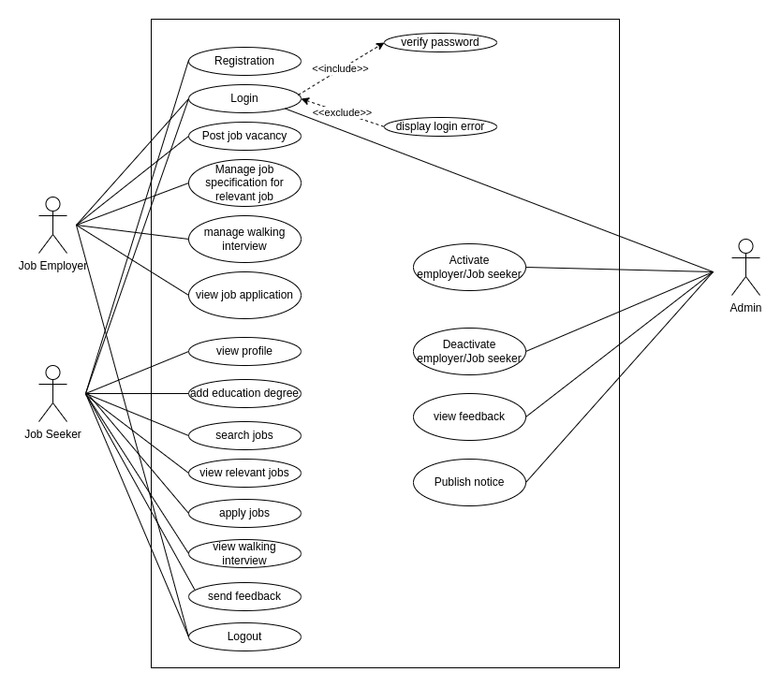

Figure 2: Functional requirement module

**3.1.1.2 Non-Functional Requirements**

Non-functional requirements are not directly related to the functions performed by the system. Simultaneously, Non-functional requirements may relate not only to the software system itself some may relate to the technological process of creating software.

**1. Usability:** The system should be easy to use and intuitive for both job seekers and employers, with clear navigation and user-friendly interfaces.

**2. Performance:** The system should provide fast response times and be able to handle a high volume of traffic and user data.

**3. Security:** The system should be secure, protect user data, and prevent unauthorized access or breaches.

**4. Scalability:** The system should be able to handle a growing number of users and job opportunities without sacrificing performance or user experience.

**5. Compatibility:** The system should be compatible with multiple web browsers, operating systems, and devices.

**6. Compliance:** The system should comply with Nepalese labor laws and regulations and provide job recommendations that comply with them.

**7. Maintainability:** The system should be easy to maintain and upgrade, with clear documentation and efficient code.

**3.1.2 Feasibility Analysis**

After the proper requirement gathering was done, we conducted the feasibility analysis of the project to identify whether the project is feasible in every aspect and whether the project is possible to proceed in each aspect before starting the major work of the project. A feasibility study is an evaluation of a proposed project or system to determine whether it is practical, viable, and worth pursuing. In the context of a job recommendation system, a feasibility study might consider a range of factors, including technical, economic, operational, and legal considerations. Various feasibility analyses are discussed below:

**3.1.2.1 Technical**

From a technical perspective, a job recommendation system is feasible since the necessary technologies and infrastructure are available or can be developed. Since this system is able to handle large amounts of data and traffic, use similarity algorithms and data analysis techniques, and provide fast response times and reliable performance, this is technically feasible.

**3.1.2.2 Operational**

Operational feasibility refers to whether the job recommendation system can be integrated into the existing business processes and workflows. Since this system is highly needed by both the job seeker and employer and can benefit both parties, it can be considered highly operational. The system is easy to use and intuitive for both job seekers and employers. The system can also be made compatible with other relevant systems or applications, such as applicant tracking systems or social media platforms.

**3.1.2.3 Economic**

Our system is economic friendly and feasible since the system development, implementation costs, maintenance costs and other associated costs are comparatively cheap. It does not require large number of manpower and resources. It also helps both user parties on time and cost saving, increased efficiency and productivity. Overally, our system can self-sustain and is economically feasible.

**3.1.2.4 Schedule**

The schedule of the project was analyzed by drawing the Gantt chart through Microsoft Excel.

**Table 1 Table of the task schedule**

|  |  |  |  |
| --- | --- | --- | --- |
| **Task** | **Start Date** | **Duration (days)** | **End Date** |
| Documentation | 11th Dec | 92 | 13th Mar |
| Requirement Gathering | 11th Dec | 5 | 16th Dec |
| System Design | 17th Dec | 14 | 31th Dec |
| Incremental Implementation | 1st Jan | 56 | 26th Feb |
| Verification & Testing | 28th Feb | 8 | 8th Mar |
| Deployment | 9th Mar | 2 | 11th Mar |

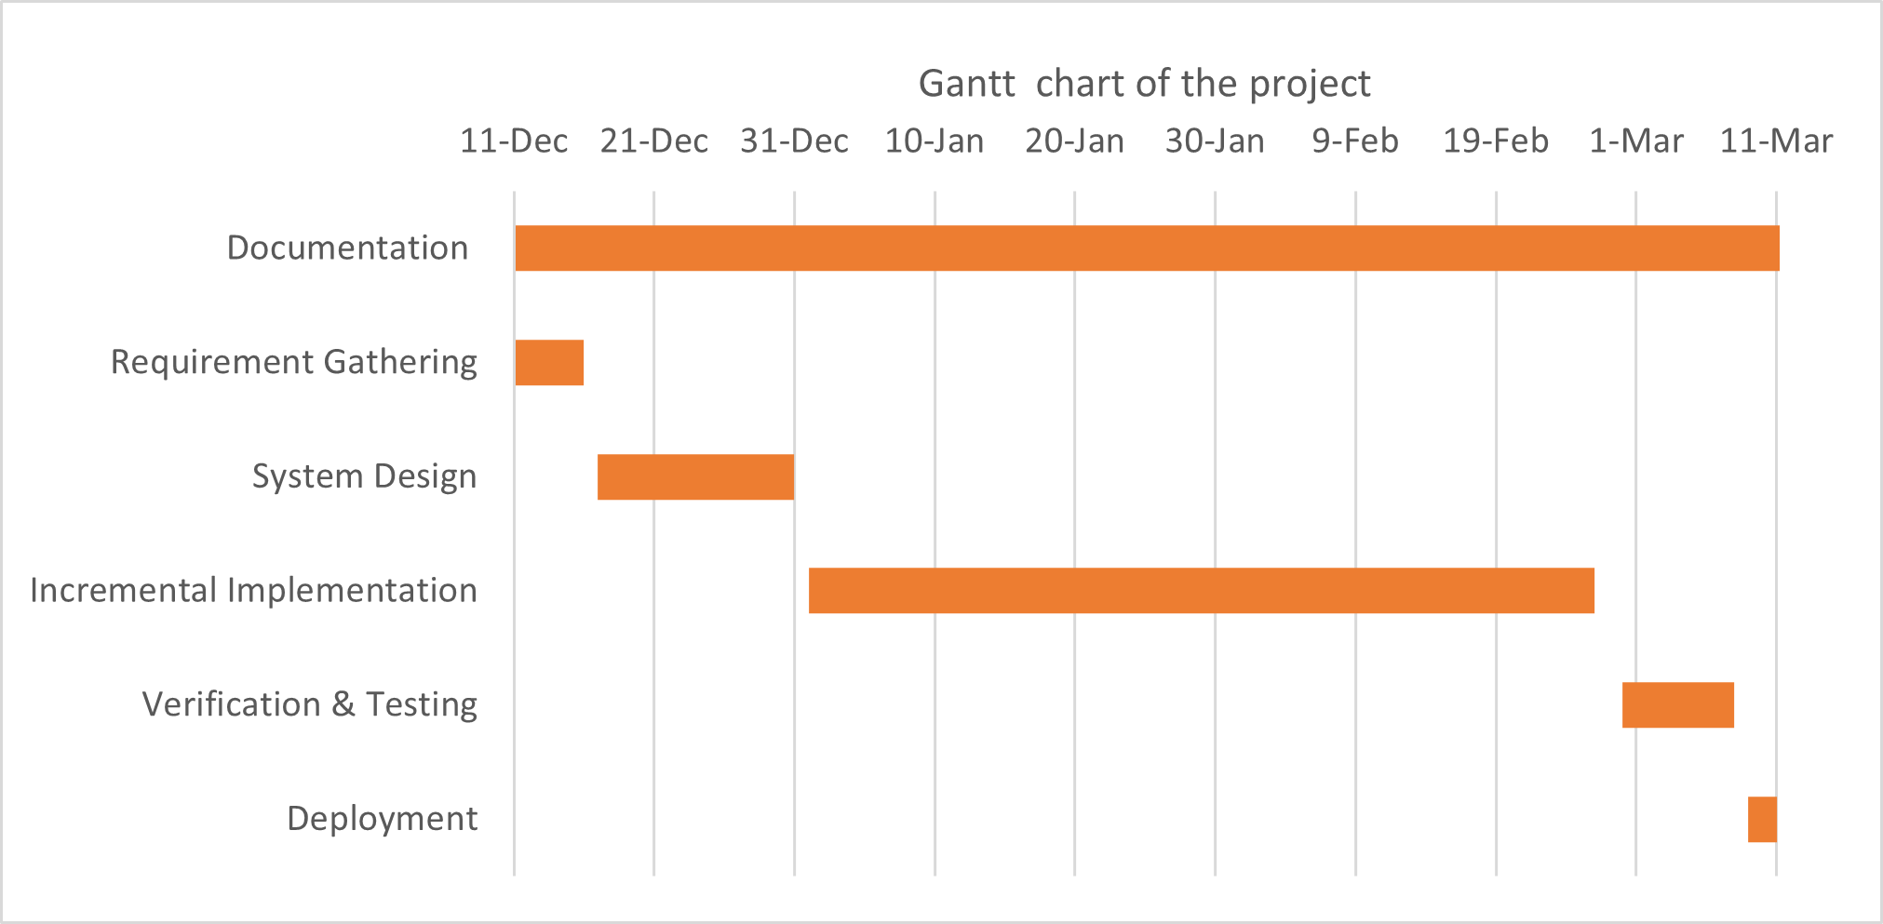

Figure 2 Gantt chart of the project

While analyzing the Gantt chart of the project it was found that the project can be completed on a fixed schedule so the project was found feasible on the time aspect.

**3.1.3 Analysis**

After we conducted the feasibility study, we identified that the project was feasible from every aspect and there may not arise any major hindrance during the execution of the project. After we got the assurance that the project was feasible, we conducted a thorough system analysis of the project before starting the implementation of the project. When conducting the system analysis, the team decided to implement the project through structured approach though Object Oriented is applied for the algorithm part. Also in the analysis period, various system diagrams like ER Diagram, use case Diagram and DFD Diagram were sketched by the team to analyze the system to be developed.

**3.1.3.1 Data Modeling (ER Diagram)**

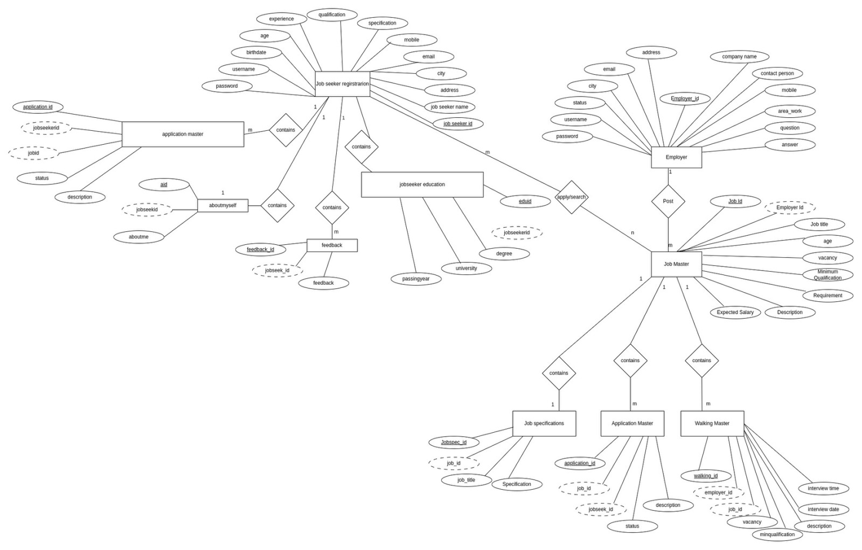

Figure 1 . ER Diagram

**3.1.3.2 Process modeling using DFD**

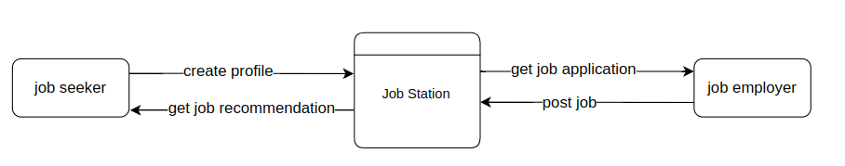

Figure 4. 0-level DFD

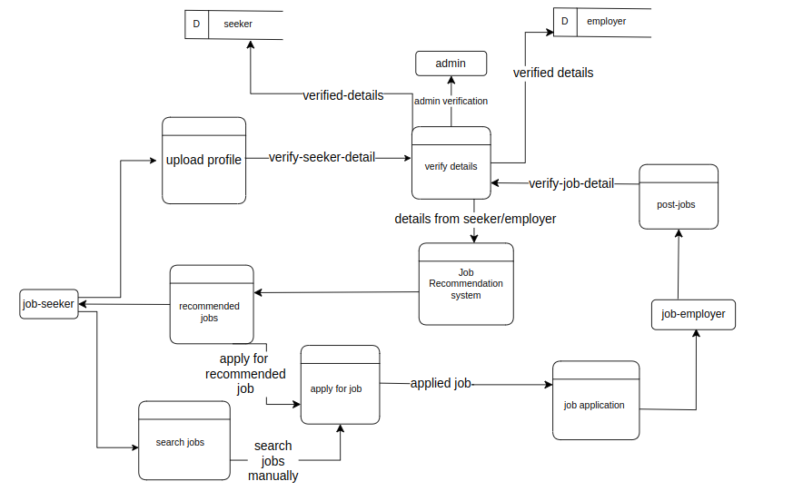

Figure 5. 1-level DFD

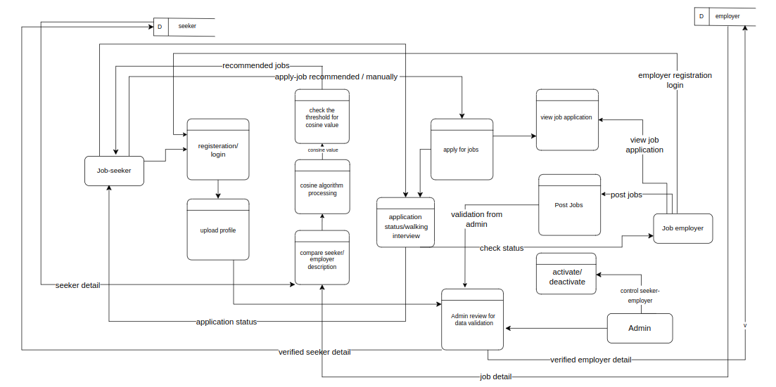

Figure 5. 2-level DFD

**CHAPTER 4  
SYSTEM DESIGN**

**4.1 Design**

**4.1.1 Database Design**

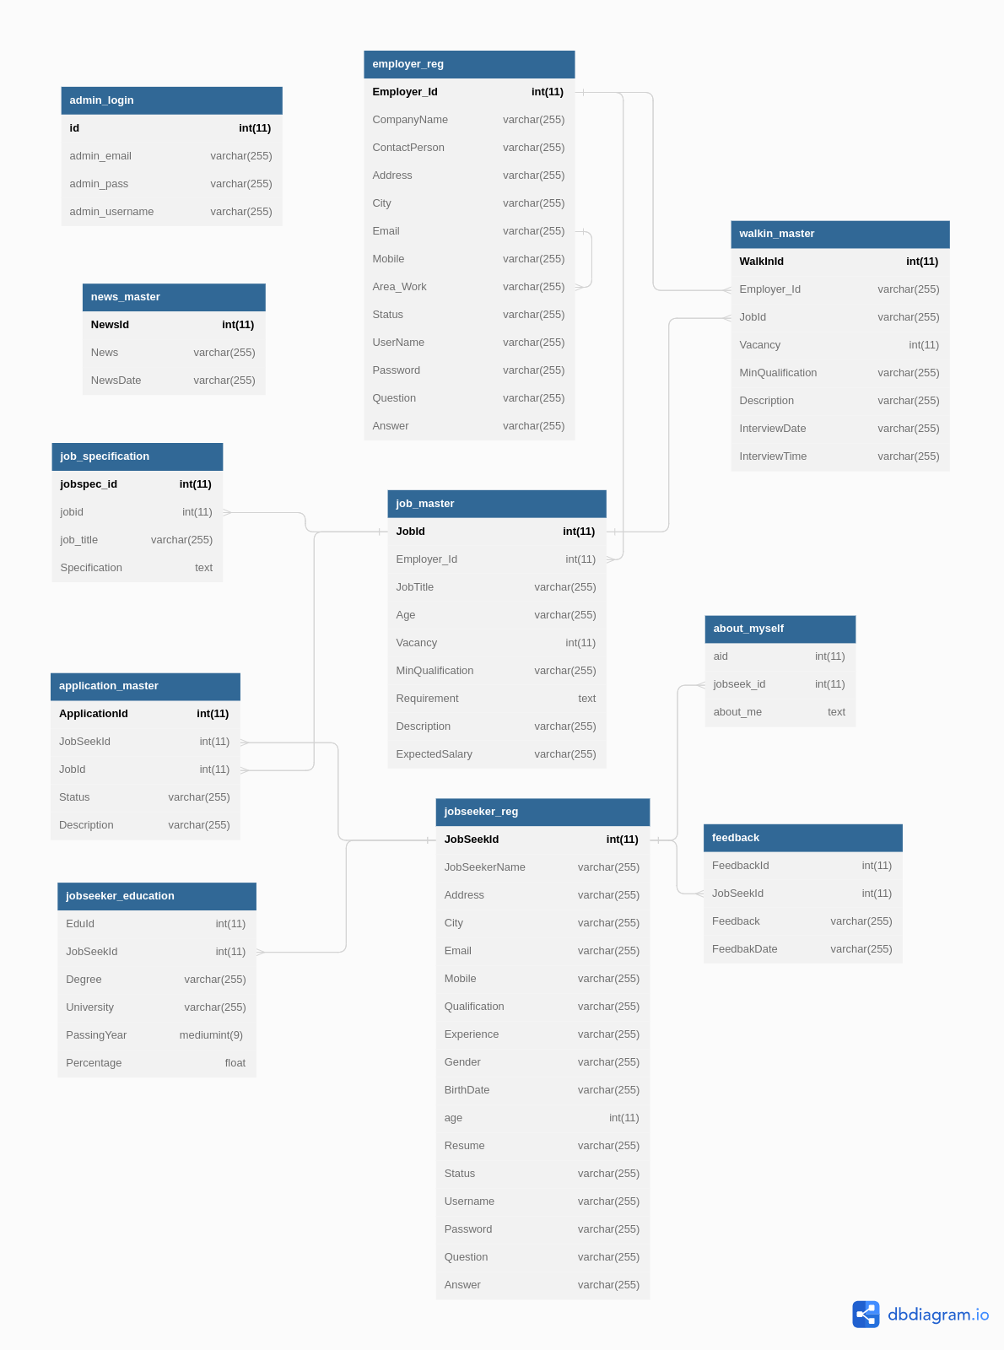

Figure 7. Database Design

**4.1.2 Forms and Report Design**

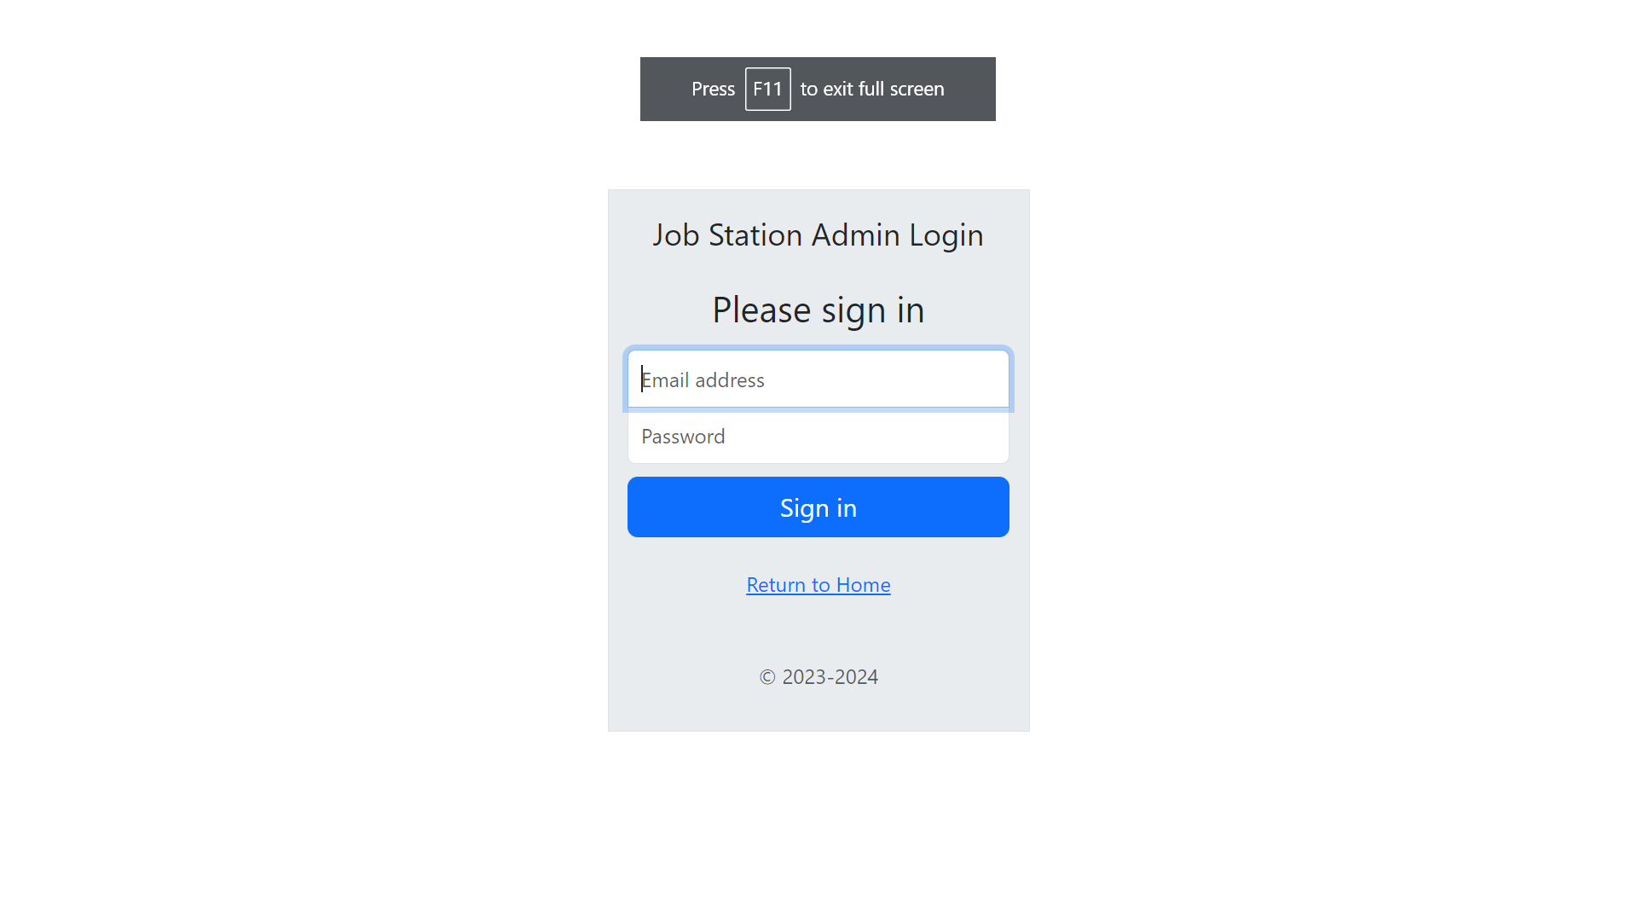

Figure 8 Admin Login Form

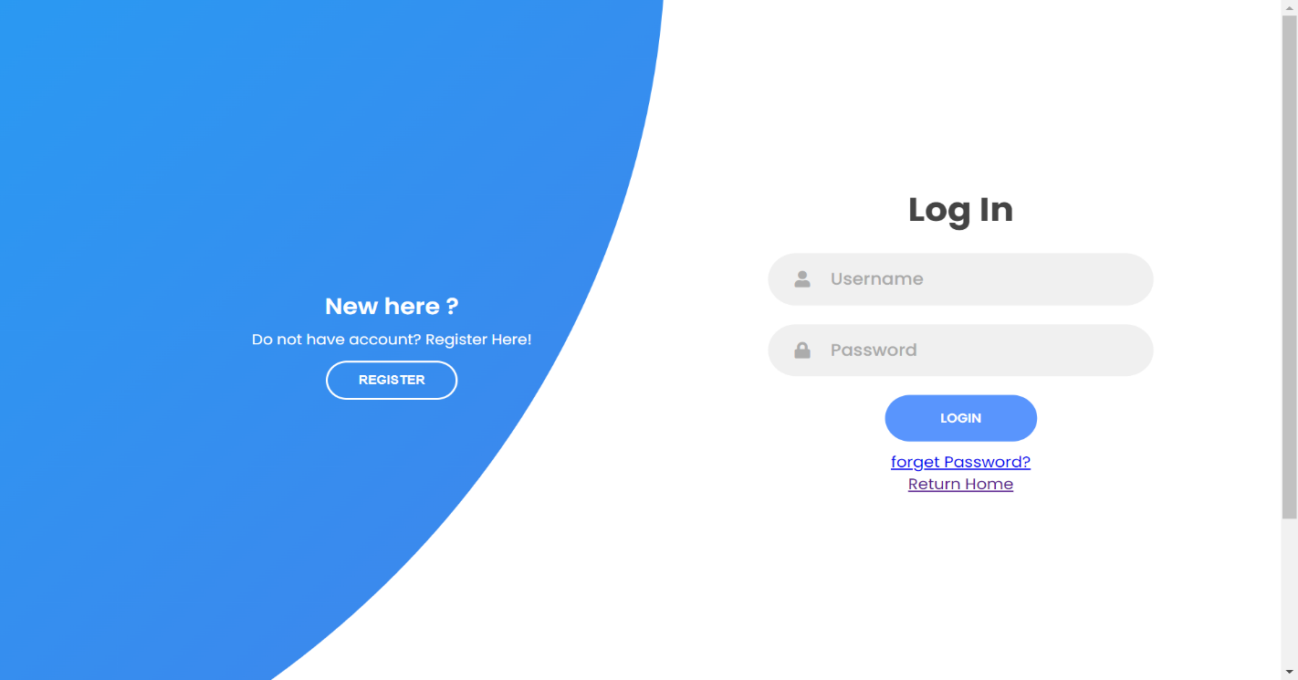

Figure 8. Employer Login Form

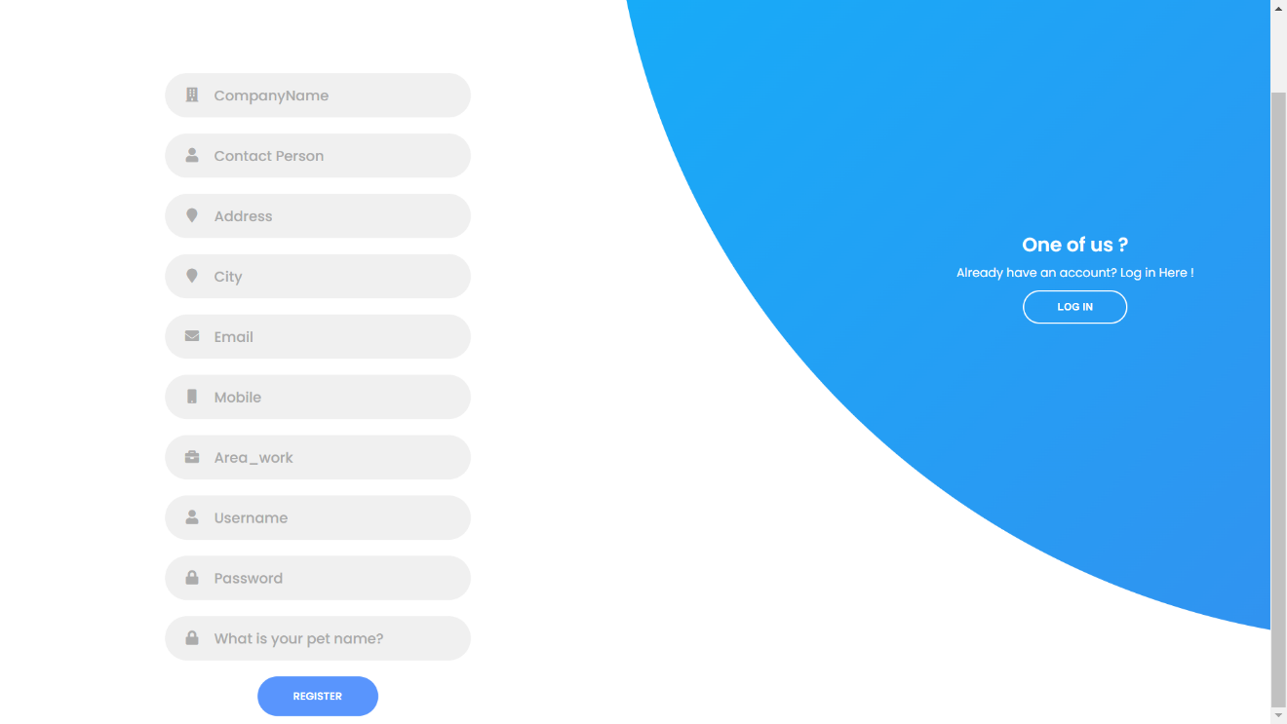

Figure 8. Employer Registration Form

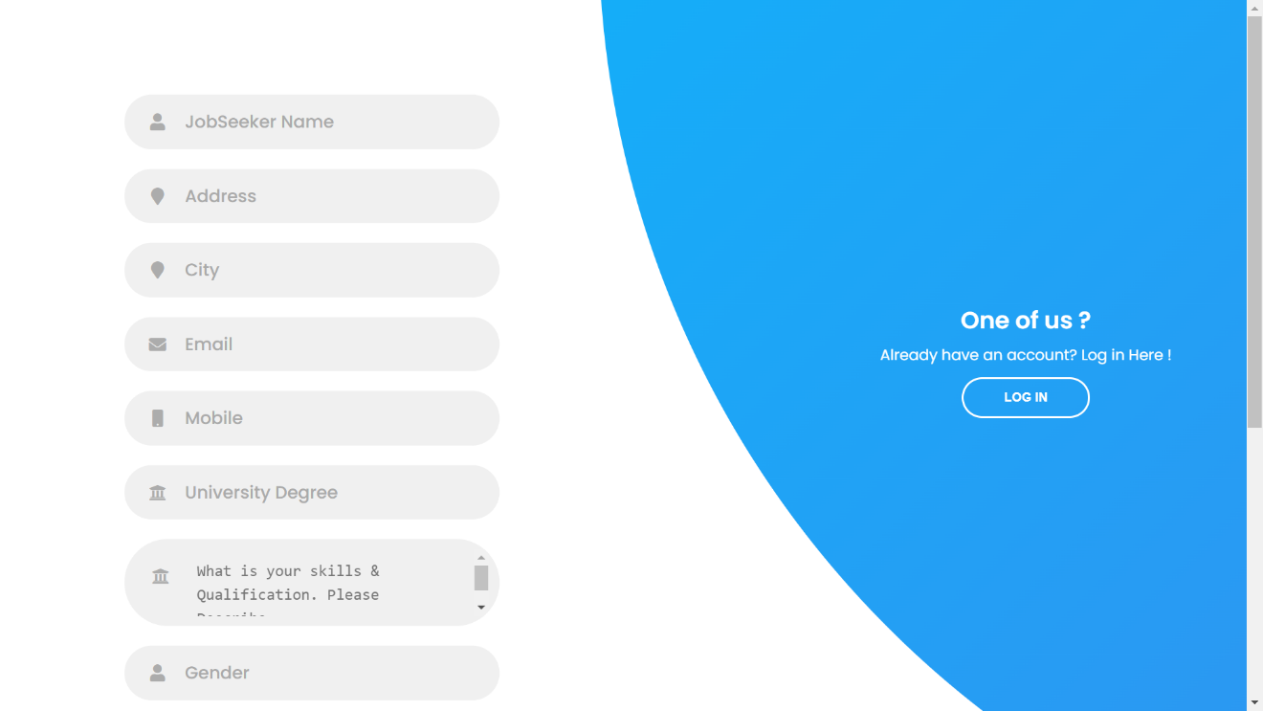



Figure 9. Job Seeker Registration Form

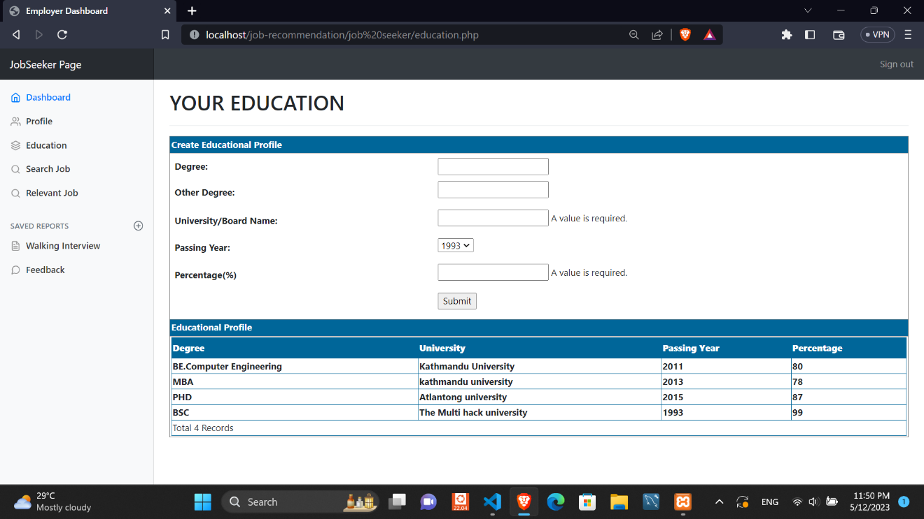

Figure 9. Job Seeker Education Form

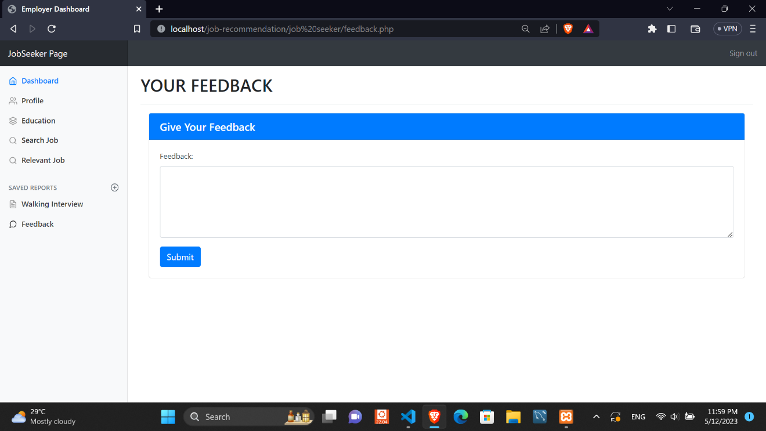

Figure 9. Job Seeker Feedback Form

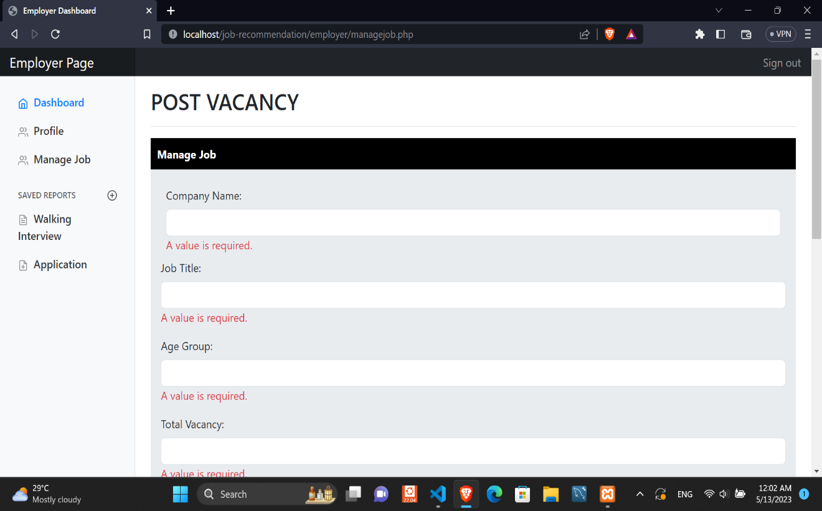

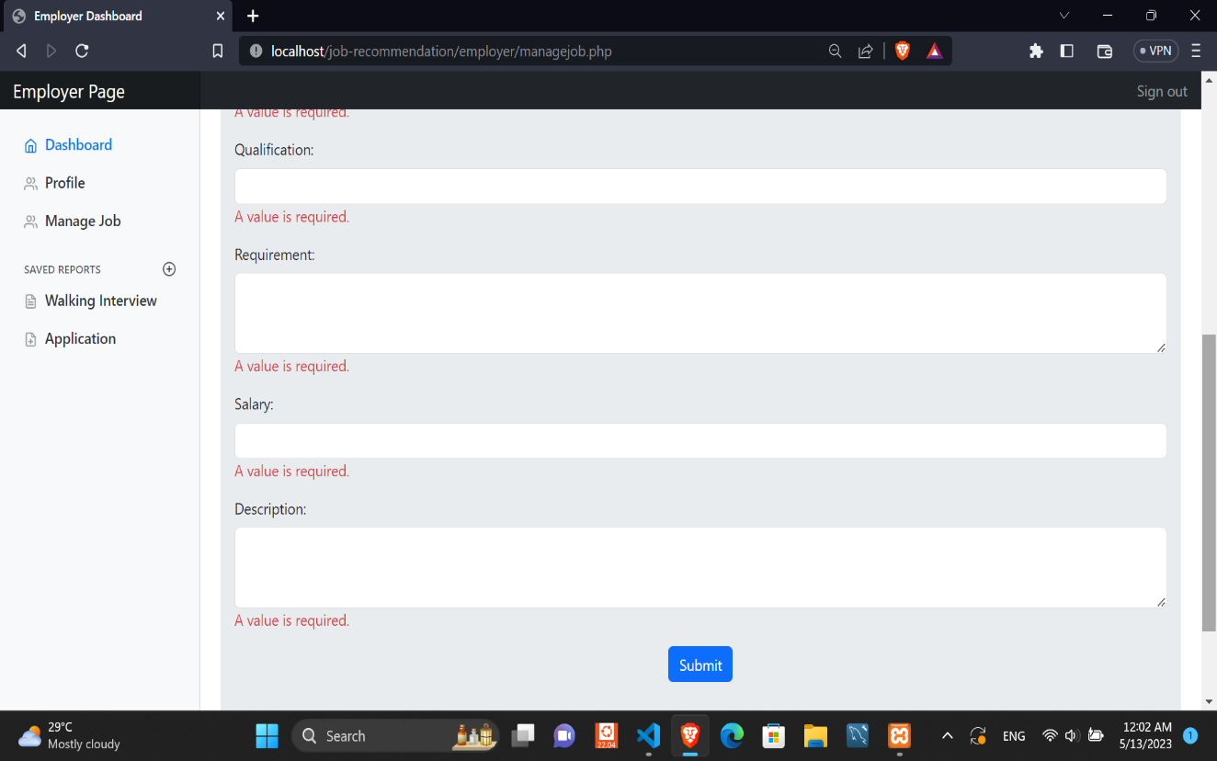

Figure 10. Job Employer new Job post Form

**4.1.3 Interface Design**

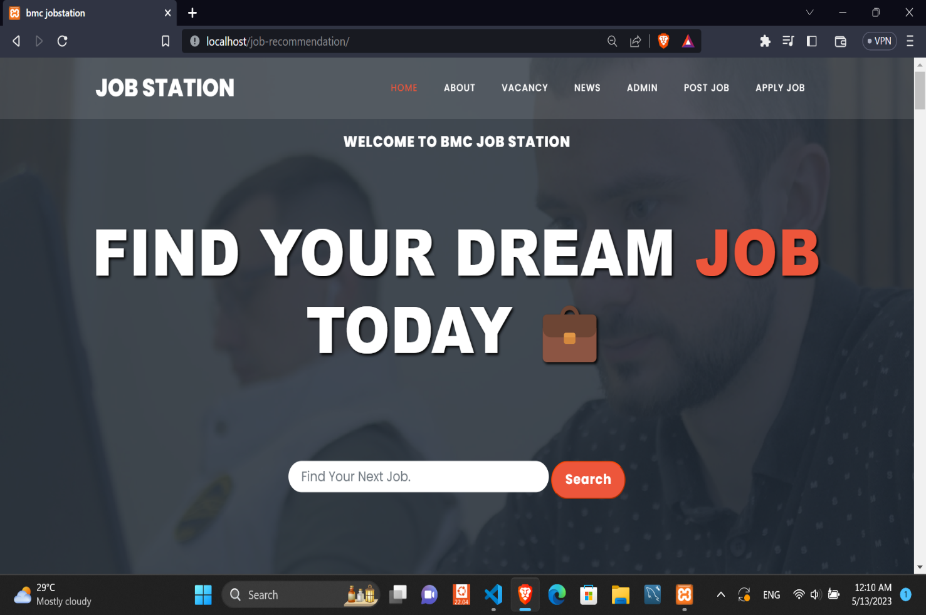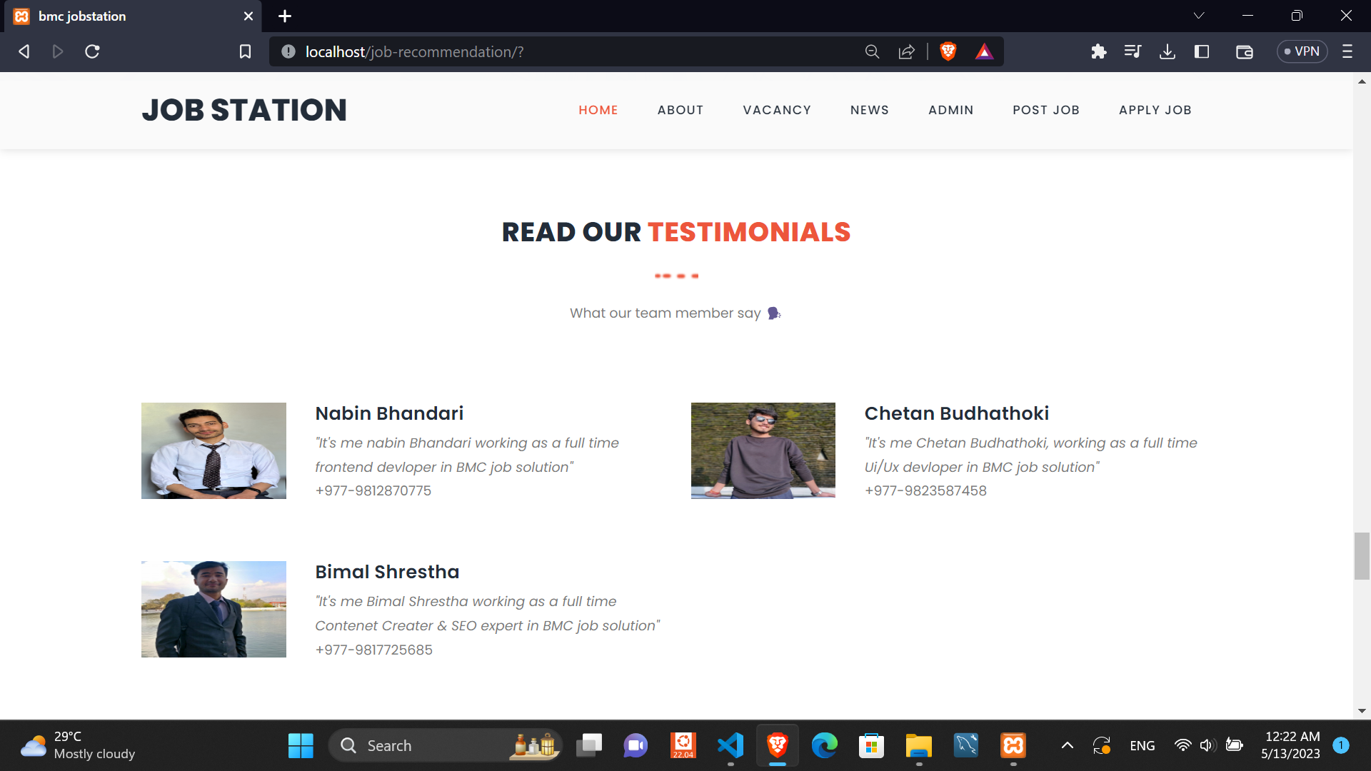

Figure 10. Home page

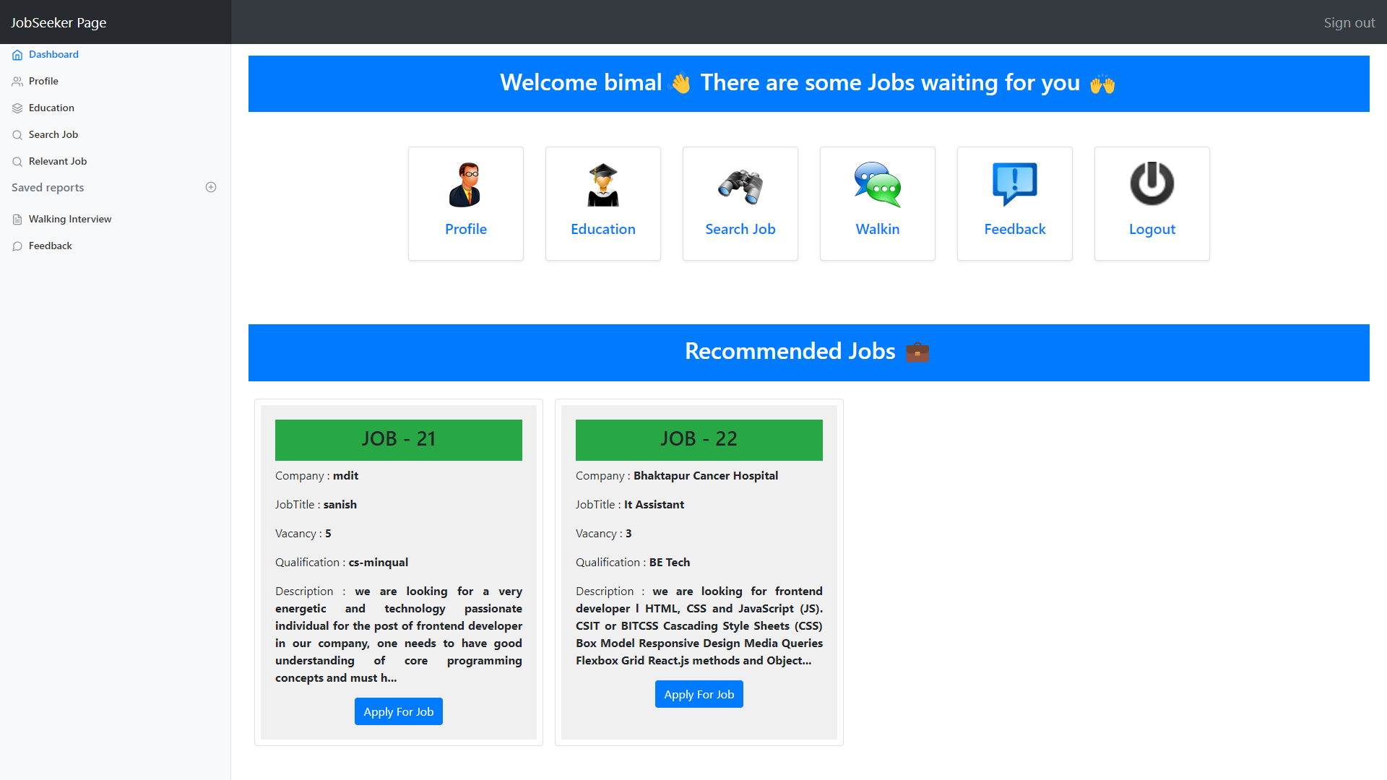

Figure 11. JobSeeker Hompage

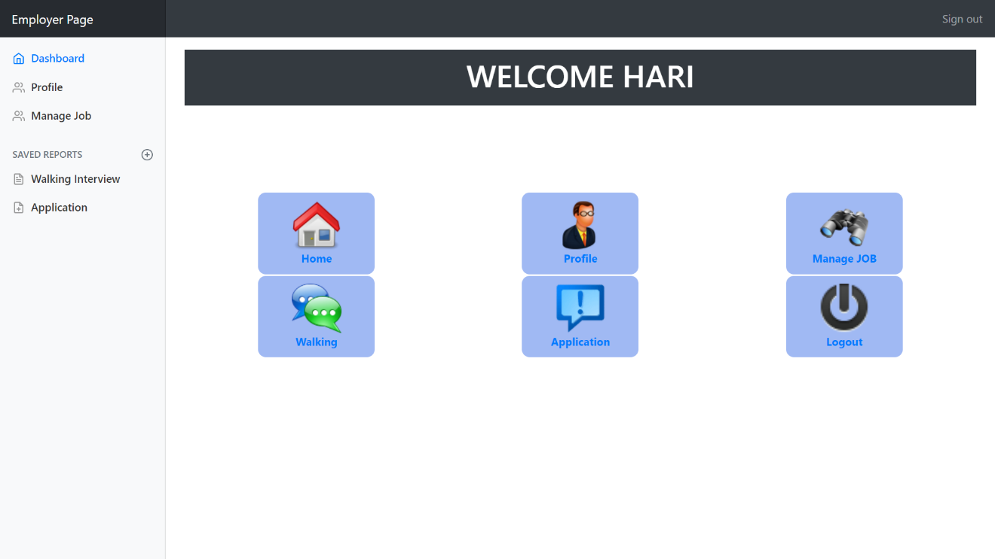

Figure 11. Employer Hompage

**4.2 Algorithm Details**

**4.2.1 Cosine Similarity**

This concept is used in this project to calculate the score between two document vectors. The similarity between two vectors is defined by the angle between them. If the angle between two vectors is zero and thus cosine=1, representing the perfect match. If those two vectors are perfectly dissimilar, then the angle between the vectors is perfect 90 degree and cosine=0, representing the perfect dissimilar. The inputs required for cosine similarity calculation must be represented in the form of a Vector Space Model. A Vector Space Model is the mathematical structure formed by a collection of vectors.

In this recommendation system we have implemented the cosine similarity between job seeker’s bio data and job specifications that is related to different jobs. For calculating cosine similarity, we have to convert these two texts (bio, specification) into document vectors. In order to obtain document vectors, we use the concept of term frequency.

**4.2.1.1 Term Frequency**

Term frequency is a measure of how often a term is found in the collection of documents. A reasonable scoring mechanism is computed with document terms. It counts the frequency of the terms that match between the query terms and the document term list which is denoted by tf(t, d).

**4.2.1.2** **Calculation Process**

Here we consider,

text1 = [bio data of a job seeker]

text2 = [job specification or requirement by employer]

i.e

$text1 = “Computer Engineer BscCSIT HTML CSS JS”

$text2 = “Front End Developer HTML CSS JS BscCSIT”

Step 1:

Using the explode function for conversion of text into Array:

$array_text1=[‘Computer’, ‘Engineer’,’BscCSIT’,’HTML’,’CSS’,’JS’,];

$array_text2=[‘Front’, ‘End’,’Developer’,’HTML’,’CSS’,’JS’,’BscCSIT’];

Step 2:

Concatenating $array_text1 and $array_text2

array_text3 = $array_text1 . $array_text2

Step 3: Removing dublicate value and gives 0 to every possible tags.

$array_text3 = array_unique(array_text3);

$array_text3 = array_fill_keys($array_text3, 0);

$array_text3=[‘Computer=>0’, ‘Engineer=>0’, ’BscCSIT=>0’, ’HTML=>0’, ’CSS =>0’, ’JS =>0’, ‘Front=>0’, ‘End=>0’, ‘Developer=>0’];

Step 4:

Assigning key values for $array_text1 and $array_text2 using function

a$ = array_fill_keys($array_text1, 1) with key value 1.

$a = Array(

[computer]=>1

[Engineer]=>1

[BscCSIT]=>1

[HTML]=>1

[CSS]=>1

[JS]=>1)

b$ = array_fill_keys($array_text2, 1) with key value 1.

$a = Array(

[Front]=>1

[End]=>1

[Developer]=>1

[HTML]=>1

[CSS]=>1

[JS]=>1

[BscCSIT=>1

)

Step 5:

Now, it again assigns the key value for $array_text1 and $array_text2 which is 1 and it is added

with $a.

1. $array_text1=array_fill_keys($a,1) + $a

2. $arrary_text2=arrary_fill_keys($b,1) + $a

Output for $array_text1:

array(

[computer]=>1

[Engineer]=>1

[BscCSIT]=>1

[HTML]=> 1

[CSS] => 1

[JS] =>1

)

Output for $arrary_text2:

array(

[Computer]=> 0

[Engineer] =>0

[BscCSIT]=> 1

[HTML] =>1

[CSS]=>1

[JS]=>1

[front]=>1

[End]=>1

[Developer]=>1

)

Thus, we compute cosine similarity using output of array text 1 and array text 2 using following

formula:

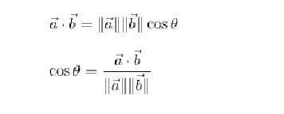

If similarity is greater than 0.5 i.e 50%, system suggests corresponding job vacancy to the jobseeker.

**CHAPTER 5  
IMPLEMENTATION AND TESTING**

**5.1 Implementation**

After completing the system design phase, where we have prepared all the necessary system designs, and studied all the necessary algorithms for the project, we implemented the blueprint and design sketches prepared from previous stages into a functional system code. The implementation details are described below:

**5.1.1 Tools Used**

Various tools used during the implementation of the project are further described below:

**5.1.1.1 CASE tools**

The various Computer Aided Software Engineering (CASE) Tools used for the implementation of the project are listed below:

**1: Diagram Tools**

For diagramming, various system designing tool during the project lifecycle, like draw.io and lucid chart were used.

**2. Documentation Tools**

For writing the documentation/report of the project, Microsoft word was used.

**3. Design tools:**

For designing various user interfaces of the web application for the project, the online web application-based Software, figma was used.

**4. Configuration Management Tools:**

To track the changes occurred in the web application and maintaining the code version during the project lifecycle, Git was used. Xampp for the server creation and database hosting.

**5.1.1.2 Programming Languages:**

For writing the code, Visual Studio Code Integrated Development Environment was used and for the web application to run and see the output, web browsers like Google Chrome were used. We have used HTML, CSS, JavaScript in Frontend, PHP as backend, MySQL as database

And XAMPP as a server for serving files and database.

**5.1.2 Description of Implementation Modules of the System**

**1. Data collection module:** Collects job seeker and job opening data from various sources such as user profiles, company profiles. Store the data in a database.

**2. User profile module:** Create user profiles based on job seekers' skills, experience, and job preferences. This can be done by calculating the cosine similarity between the job seeker's profile and the job opening profiles. The user profile can be represented as a vector of weighted attributes.

**3.Job opening profile module:** Create job opening profiles based on the requirements, responsibilities, and qualifications of the job openings. This can also be done by calculating the cosine similarity between the job opening's profile and the job seeker profiles. The job opening profile can also be represented as a vector of weighted attributes.

**4. Recommendation engine module:** Generate job recommendations for job seekers based on their user profiles and job opening profiles using cosine similarity. The recommendation engine can compare the cosine similarity values between the job seeker's profile and all job opening profiles in the database to generate a list of recommended job openings.

**5. Evaluation module:** Evaluate the performance of the recommendation engine by measuring the precision, recall, and accuracy of the recommendations generated using cosine similarity.

**6. User interface module:** Provide an interactive user interface for job seekers to view and apply for recommended job openings. It is done using a web development tools such as HTML, CSS, JS.

**7. Database module:** Store and manage the data collected, preprocessed, and generated by the system using a database management system such as MySQL or PostgreSQL.

Overall, the implementation module for our system involves collecting and preprocessing data, creating user and job opening profiles, generating recommendations using cosine similarity, evaluating the recommendation engine, providing a user interface for job seekers, and storing data in a database.

**5.2 Testing**

Testing is a process of executing a program with the intent of finding bugs that makes the application fail to meet the expected behavior. Regardless of the development methodology, the ultimate goal of testing is to make sure that what is created does what it is supposed to do. Testing plays a critical role for assuring quality and reliability of the software. We have included testing as a part of the development process. The test cases should be designed with maximum possibilities of finding the errors or bugs. Various levels of testing are as follows.

**5.2.1 Test Cases for Unit Testing**

We have designed and executed a few test cases to check if the application meets the functional requirements.

Below are the test cases for Online Job Recommendation System application.

Table 1: Unit Test Cases for application

|  |  |  |  |
| --- | --- | --- | --- |
| **TEST MODULE** | **TEST CASE** | **EXPECTED RESULT** | **TEST RESULT** |
| ADMIN | Provide valid login credentials | User successfully logged in and directed to the admin dashboard page. | PASS |
| ADMIN | Enters invalid login credentials | Displays error message | PASS |
| ADMIN | Upon successful login, click on the ‘Manage Employer’ tab | Display the list of employers whose account registration is to be verified | PASS |
| ADMIN | Upon successful login, click on the ‘Manage Job Seeker’ tab | Display the list of seekers whose account registrations to be verified | PASS |
| ADMIN | Upon successful login, click on the ‘Public No’ tab | Can publish new news and edit and delete existing news | PASS |
| ADMIN | Upon successful login, click on the ‘Feedback’ tab | Can view the feedbacks send by employers and seekers | PASS |
| EMPLOYER | Provide details for registration | Employer registration successfully submitted | PASS |
| EMPLOYER | Upon successful login, click on ‘Manage Jobs’ tab | Employer posts jobs with the required details and view the details of all the posted jobs | PASS |
| EMPLOYER | Upon successful login, click on ‘Walking Interview’ tab | Employers post job vacancies that have to be attended physically and also can view the list of previously posted jobs | PASS |
| EMPLOYER | Upon successful login, click on ‘Profile’ tab | Can view as well as edit information about themselves | PASS |
| EMPLOYER | Upon successful login, click on ‘APPLICATION’ tab | Can view the list of applications send by applicants or PASS seeker for a particular job as well as can reply all later message to the applicant | PASS |
| JOBSEEKER | Provide details for registration | Job Seeker registration successfully submitted | PASS |
| JOBSEEKER | Enters invalid login credentials | Enters invalid login credentials | PASS |
| JOBSEEKER | Upon successful login, click on ‘ Profile’ tab | List details of jobseeker | PASS |
| JOBSEEKER | Upon successful login, click on ‘Search Jobs’ tab | Can search for different job vacancies that are  available and also view status of previously applied jobs | PASS |
| JOBSEEKER | Upon successful login, click on ‘Walking Interview’ tab | Can view the list of vacancies which should be attended physically | PASS |
| JOBSEEKER | Upon successful login, click on ‘Education’ tab | Can add their educational degrees | PASS |
| JOBSEEKER | Upon successful login, click on ‘Feedback’ tab | Can send feedbacks to administrator | PASS |

**Test Objectives:** Successfully submits the job application

Table 1: Test Case for applying job

|  |  |  |  |
| --- | --- | --- | --- |
| **TEST CONDITION** | **INPUT SPECIFICATION** | **OUTPUT SPECIFICATION** | **TEST RESULT** |
| The user is currently on the jobs page | User clicks on the “APPLY” tab against a job post | Prompts a message as “Successfully applied to this job” | PASS |

**Test Objectives:** User Checks for applied jobs.

Table 1: Test Case for listing all jobs

|  |  |  |  |
| --- | --- | --- | --- |
| **TEST CONDITION** | **INPUT SPECIFICATION** | **OUTPUT SPECIFICATION** | **TEST RESULT** |
| The job seeker is currently logged into their account | The job seeker clicks on search job tab | Lists all the jobs that are applied | PASS |

**5.2.2 Test Cases for System Testing**

System testing is a type of testing that evaluates the complete software system as a whole to ensure that it meets its functional and non-functional requirements and specifications. Below are the test cases for System Testing for our Job Recommendation System application.

**Test Objectives:** Test the system's ability to handle a large volume of job seekers and job postings

Table 1: Test Case for handling a large volume of data

|  |  |  |  |
| --- | --- | --- | --- |
| **TEST CONDITION** | **INPUT SPECIFICATION** | **OUTPUT SPECIFICATION** | **TEST RESULT** |
| To handle a large volume of job seekers and job postings | By feeding large number of job seekers and job posts. Number of job seekers should be registered and number of jobs should be posted. | System is able to handle those large number of data | PASS |

**Test Objective:** Test the accuracy of the job recommendations

Table 1: Test Case for the accuracy of the algorithm

|  |  |  |  |
| --- | --- | --- | --- |
| **TEST CONDITION** | **INPUT SPECIFICATION** | **OUTPUT SPECIFICATION** | **TEST RESULT** |
| To check the accuracy of the job recommendations system. | By feeding relevant data to the system at jobseeker and job posting end. | If similarity is greater than 0.5 i.e 50%, system suggests corresponding job vacancy to the jobseeker. | PASS |

**CHAPTER 6**

**CONCLUSION AND FUTURE RECOMMENDATIONS**

**6.1 Conclusion**

The major goal of this project is to provide a web-based system where Job Seekers can find the relevant jobs based on their profile specifications and employers can manage and select the right candidate for their jobs by viewing their profile and resumes.

It is a web-based application developed using Html, CSS, JavaScript, Bootstrap for its front end, PHP for its backend and MySQL for databases.

People are unable to get access to job opportunities due to inefficient distribution of information on job offers but now the Internet has made a huge impact on knowledge management and information dissemination all over the world. It is expected to use less budget and less resources and can be easily access by every user because of its user-friendly environments and also the system is not so complex for users. Any person who has access to the Internet can access information anywhere in the world. This system aims and objective is to provide a platform where recruiters and job seekers can communicate.

The development and implementation of the system provides the following features:

• User authentication

• CV or resume upload

• Feedback mechanism

• Find relevant jobs

**6.2 Future Recommendations**

This project fulfills the primary requirements of the job seekers and employers. It can be extended in several ways. It can provide recommendations and email updates for new job postings based on the job seeker’s search history. Since the job seekers might be interested in building a strong resume, it can provide tips and information for the same. It can also provide templates for building the Resumes which might interest most applicants. The mobile application is developed fulfilling the functionalities of job seekers, it can be extended to support functionalities of Employers as well.

In this system, Cosine Similarity is calculated using the term frequency of each term in job seeker biodata. But Term frequency suffers from critical problems as all the terms are considered equally important. In fact, Certain terms have little or no selective power in determining relevance. And also, terms which appear very few in number have higher probability in determining the relevance. So, to overcome this problem we have to scale down the term weight of the terms with high collection frequency. For this we can use TF-IDF weighting instead of term frequency which can improve the outcome of our system.

**Reference**

1. Abhjit Roy, “Introduction to recommender system-1:Content-Based Filtering And Collaborative Filtering”.[Online]

Available:https://towardsdatascience.com/introduction-to-recommender-systems-1- 971bd274f421. [Accessed 09 Feb 2023].

2. K. Lakiotaki, ”UTA-Rec: A Recommender System based on Multiple Criteria Analysis,” RecSys’08, pp. 219-225, 2008.

3. S. O. P. Mucheol Kim, “Group affinity based social trust model for an intelligent movie recommender system,” Multimedia Tools and Applications, vol. 64, no. 2, pp. 505-516, May, 2013.

4. R. S. Punam Bedi, “Trust based recommender system using ant colony for trust computation,” Expert Systems with Applications: An International Journal, vol. 39, no. 1, pp. 1183-1190, January, 2012.

**ANNEX I: QUESTIONNAIRE**

1. Do you prefer applying for jobs online or physically visiting job houses?

2. What kind of job are you interested in?

3. What features do you expect in an online job site?